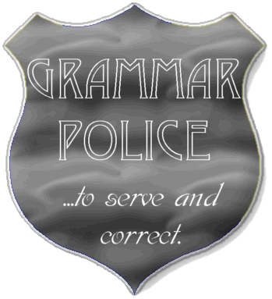
Literacy Homework
Date Set: Tues 17th November Date Due: Mon 23rd November
Please use a pen to neatly complete your homework in your Literacy homework book.
=================================
Punctuation : Copy out each of the following sentences in joined handwriting, adding all of the missing capital letters and inverted commas for speech.

1. “Great Neptune’s beard!” exclaimed Flavia’s father, softly.
2. “No, it can’t be a boy. Look how fast it’s climbing now,” exclaimed Jonathon.
3. Excitedly, Flavia squealed, “That’s him! That’s the man we saw at the tomb.”
4. “They’re in the graveyard again,” cried Mordecai, “but this time i’m ready for them!”
==================================
Grammar: Copy out each of the following sentences and underline the noun(s) in each one.

5. Flavia gazed suspiciously at the tombs around them.
6. Doctor Mordecai and Captain Geminus led the children to the harbour.
7. Seagulls and swifts soared above the river.
8. Libertus had straight black hair, clear skin and dark blue eyes.

